**Class Assignment 01**

Create a program to collect and display the following information from the user:

**Name (String)**

**Gender (Char)**

**Age (Int)**

**MobileNo (Long)**

**Cgpa (Double**)

**Output:**

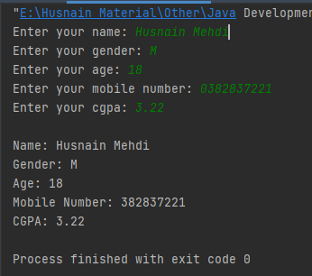

**Code:**

package com.company;  
import java.util.Scanner;  
  
public class ClassAssignment01 {  
  
 public static void main(String[] args) {  
  
 //Declaring variables  
 String name;  
 char gender;  
 int age;  
 long mob_no;  
 double cgpa;  
  
 Scanner sc = new Scanner(System.*in*);  
  
 //Taking Inputs  
 System.*out*.print("Enter your name: ");  
 name = sc.nextLine();  
  
 System.*out*.print("Enter your gender: ");  
 gender = sc.next().charAt(0);  
  
 System.*out*.print("Enter your age: ");  
 age = sc.nextInt();  
  
 System.*out*.print("Enter your mobile number: ");  
 mob_no = sc.nextLong();  
  
 System.*out*.print("Enter your cgpa: ");  
 cgpa = sc.nextDouble();  
  
 System.*out*.println();  
  
 //Printing Output  
 System.*out*.println("Name: " + name);  
 System.*out*.println("Gender: " + gender);  
 System.*out*.println("Age: " + age);  
 System.*out*.println("Mobile Number: " + mob_no);  
 System.*out*.println("CGPA: " + cgpa);  
 sc.close();  
  
 }  
}